There are two data files. One for unweighted graphs and one for weighted graphs.

The data is structured in the following way:

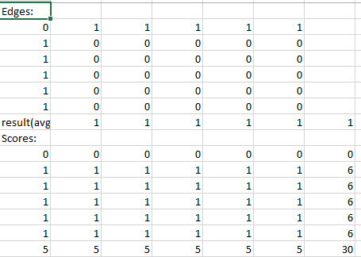

The edges map, it tells us which nodes are connected by an edge; in this example all nodes are connected to node 0.

Result(avg) tells us what the average result was ( for 0: 200 game turns were reached, for 1: the graph stopped changing before 200 turns)

This tells us if we should increase the turn limit.

Score tells us the average result of the simulation. The rows represent the initial defector while the columns represent the node, the last row and column are the sums of the previous ones, on all the others cells we record the average result (from 0 to 1) in this example when node 0 was the initial defector all nodes turned into defector while in all other cases they all turned into cooperators

For the size 6 graph there were no graphs in which for all initial defector the robustness was bigger than 0, the best performing graphs were star graphs.